2016 Graphic Coursework

Student number: 160149908

Student name: MA, CHEN-YU

Video link:

<https://youtu.be/-k61-AKSEgw>

shade the mountain in different colours:

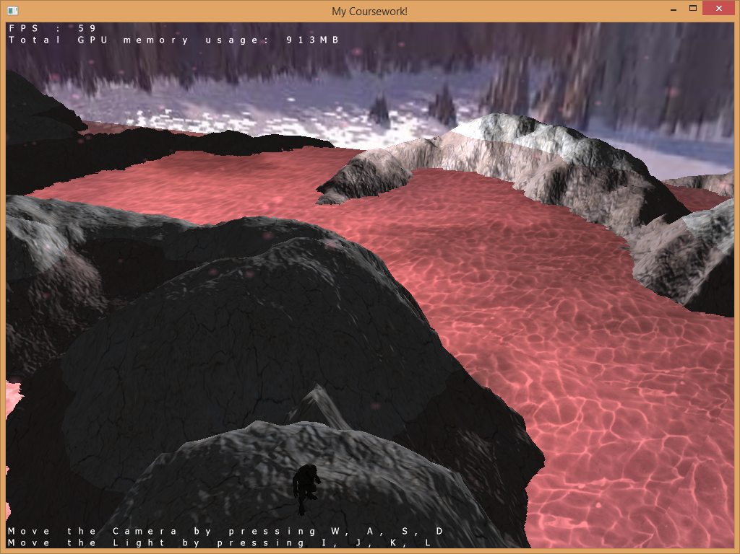

Shadows of the terrain:

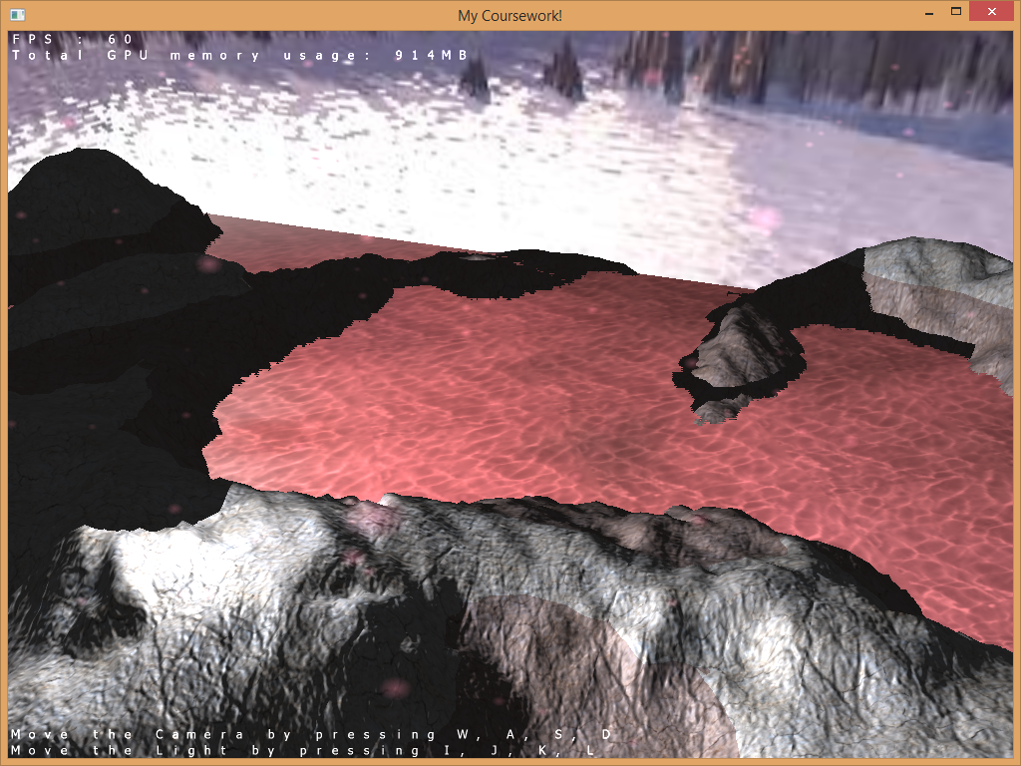

Snowing:

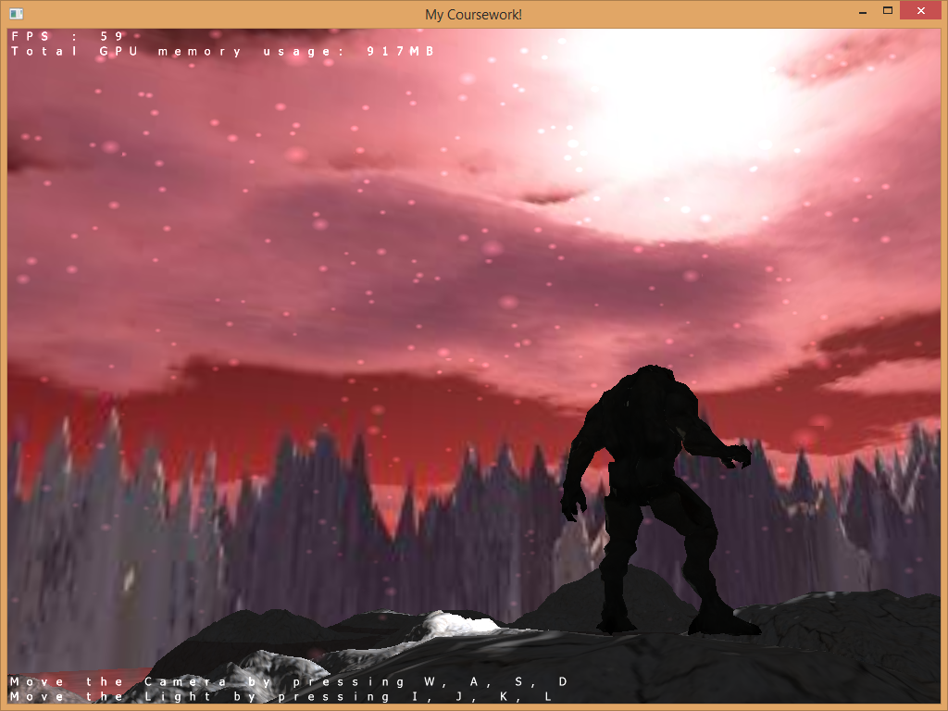

Explosion:

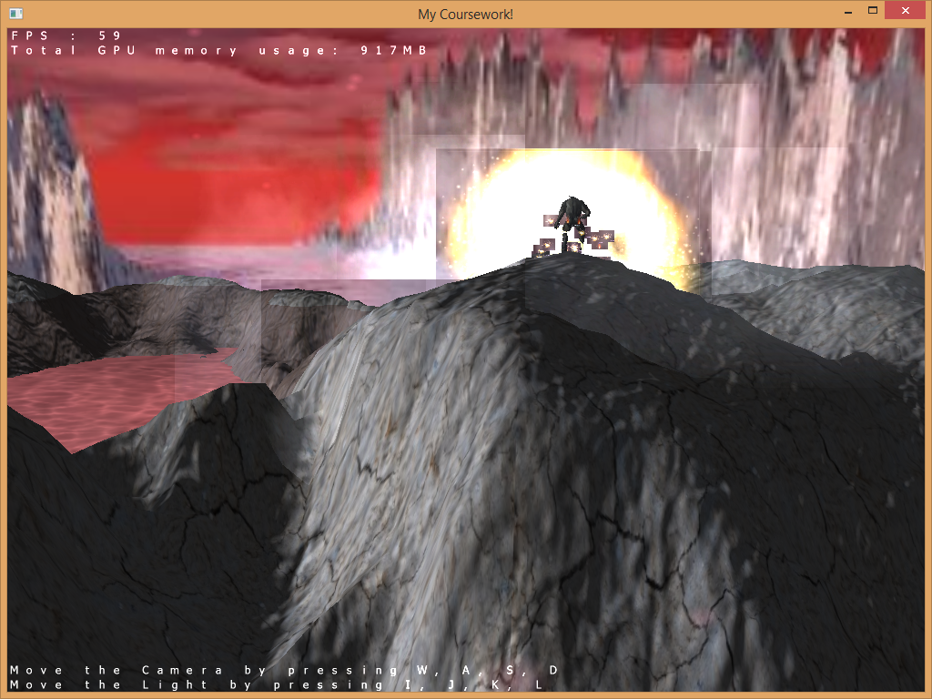

Reflection of the water:

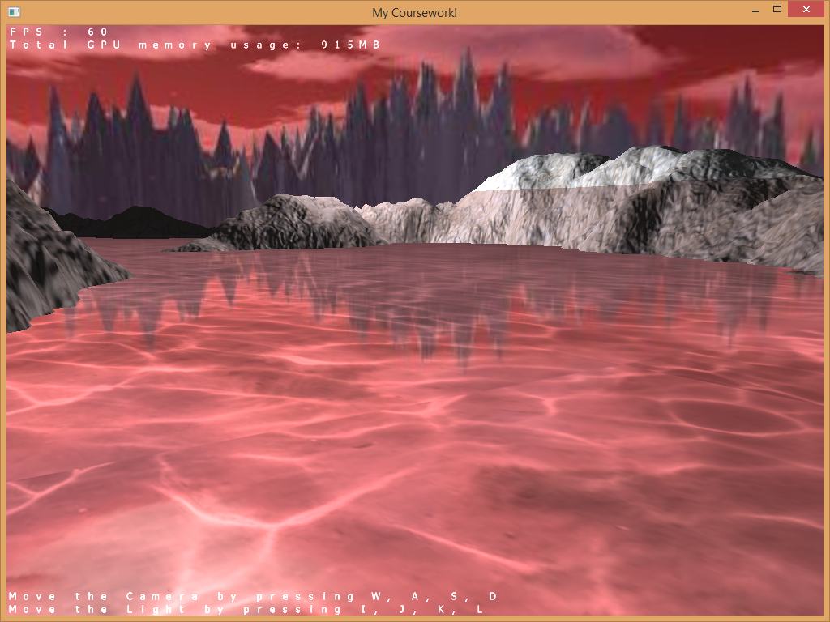

Display the current FPS and memory usage:

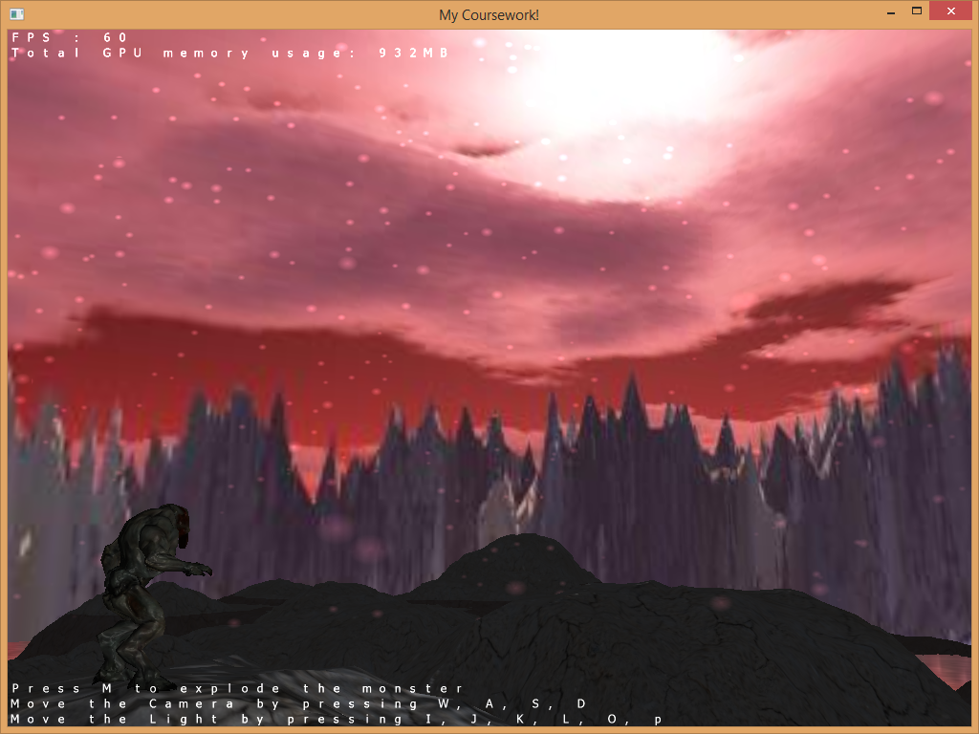

Hot spring:

